 |  |  | 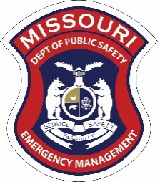
Class Title: | ICS300 – Intermediate Incident Command System
Class Date / Time: | October 2-4, 2019 / 8 am – 5pm
Sponsor(s): | Missouri State Emergency Management Agency, Barton Farm Campus Commission
Course Description: | This course addresses the functions of command within an Incident Command System (ICS). The focus of this course is on activating the necessary elements on the prolonged incident and the various forms and documentation to assist in the incident. Discussion includes the responsibilities of each section chief and the various branch, division, group and unit leaders, and includes a short review of ICS and the National Incident Management System (NIMS). This course will provide a valuable command learning experience in a ‘real-time’ learning environment. The course is highly recommended for emergency response personnel interested in learning how to effectively operate within a fully functional incident command system and meets the NIMS Integration Center requirements for ICS Level 300.  Prerequisites: IS100, IS200, IS700, and IS800.
Target Audience: | Law Enforcement, Fire, Emergency Medical Services (EMS), and Emergency Management
Location: | Barton Farm Campus  96 S E 8th Ave  Trenton, MO 64683
Class Limit: | 30
Enroll online at: | https://www.sematraining.com/courses/29/offerings/7669
For Issues or Questions Enrolling  Contact: |  | Laura Norris, State Training Officer  PO Box 116  Jefferson City, MO 65102  Phone: (573) 522-4098  Fax: (573) 526-9262
If you need assistance or special accommodations for this training, please contact Laura Norris at
(573) 522-4098, Laura.Norris@sema.dps.mo.gov or June Simonton at (573) 526-9121, June.Simonton@sema.dps.mo.gov prior to the training date.

